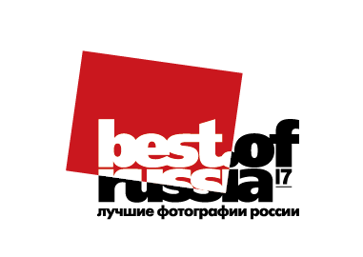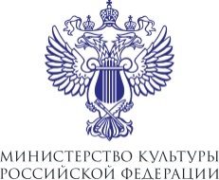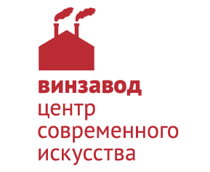
Best of Russia — 2017
Winzavod Center for Contemporary Art
White Hall / Red Hall
March 22 — May 13

The anniversary exhibition of the largest photo research of the country Best of Russia — 2017 completes the ten-year cycle of the project history.
The final exhibition is opening at Winzavod Center for Contemporary Art on March 22. The audience will see the works of the winners of 2017 and 100 best photos of the project.
Best of Russia is an unprecedented project, in which both famous and novice photographers could take part. Each year, the photo contest was held in several categories, the best images were selected by an anonymous vote of the jury of the project, then published in albums and included in expositions Best of Russia.
Over the past ten years Best of Russia exhibitions were visited by more than a million people; almost 300,000 photos and tens of thousands of authors took part in the competition. The youngest participant of the project is 6 years old and the oldest one is 92. In different years the main country’s photo exhibition was shown in Paris, Riyadh, St. Petersburg, Novosibirsk, Kaliningrad, Perm, Yekaterinburg, Ulyanovsk.
President of the Winzavod Fund for the Support of Contemporary Art Sofia Trotsenko: “Planning the project in 2007, we proceeded from the growing popularity of photography. One of the objectives of the project was formation of a promotional system of still unknown, but talented photographers. Moreover, in the ten years of the project's existence we managed to collect a unique photo archive, which documents the life of Russia”.
The anniversary exhibition is represented by two nominations, 100 best shots in the history of Best of Russia and a timeline, which has put together the most significant events of the decade, illustrated in the photos of the project.
The works of the contest 2017 are divided into two nominations: “People. Events. Everydy life” and a special theme of the year “Anniversaries”. Photographers’ attention is focused on the 205th anniversary of the battle of Borodino, the 60th anniversary of the Russian cosmonautics, the 100th anniversary of the October revolution, the 870th Moscow festival, the 200th anniversary of the artist Ivan Aivazovsky, key political and cultural events and, of course, personal anniversaries of the heroes of photos.
Curator of the project Best of Russia Lina Krasnyanskaya: “Photos of the winners of Best of Russia have always been reflecting the most important things that happened to us in ten years, everything that somehow has changed all of us. Over the years photography from a simple hobby has become a way of life for millions of people. New technical capabilities for capturing as well as new editing programs have been appearing. However, for us, the most important thing has been not just an impeccable image, but a strong emotion and a bold statement it may express. The photos presented at the anniversary exhibition, doubtless, will impress the most demanding audience».
List of members of the Expert Council of the project 2018:
- President of the Winzavod Fund for the Support of Contemporary Art Sofia Trotsenko;
- British photographer, New York Times photojournalist, the Pulitzer Prize and World Press Photo winner James Hill;
- Kommersant Photo Department director Pavel Kassin;
- Publicist, journalist Alexander Budberg;
- ARTEX.GLOBAL co-owner and CEO Vladimir Povshenko;
- Pro Lab chairman of the board of directors Nikolay Kanavin;
- Photographer, the Pulitzer Prize and World Press Photo winner Sergey Ponomarev;
- Ostengruppe, Arbeitskollektiv art director Igor Gurovich;
- Russian blogger and photographer Ilya Varlamov;
- Head of Media & Art faculty of British Higher School of Art & Design Svetlana Taylor;
- Founder and director of School of Visual Arts Natalia Udartseva.
Press center of Winzavod Center for Contemporary Art:
Daria Stepanchenko, Public Relations Manager
t +7 (495) 644-45-45
c +7 (915) 205-84-48
pr1@winzavod.ru | press@winzavod.ru

